Desk Number________

Student Number_______________________

Student Name_______________________

**School of Science and Engineering**

**FINAL EXAMINATION**

Semester 2, May, 2020

**CSC1001 Introduction to Computer Science**

Examination Duration: 120 minutes

Reading Time: 10 minutes

This examination has __3__ questions.

**Exam Conditions:**

This is a FORMAL Examination

This is a RESTRICTED OPEN BOOK Exam. Maximum of one (1) sheet of handwritten or printed notes double sided are permitted

**Materials Permitted In The Exam Venue:**

Maximum of one (1) sheet of handwritten or printed notes double sided, a scientific calculator without the functionalities of programming and file storage and a paper-based dictionary are permitted. **NO OTHER MATERIALS PERMITTED**

**Materials To Be Supplied To Students:**

1 × 12 Page Answer Booklet, one answer sheet for multiple choice questions.

**Materials To Be Handed in After Exam:**

After exam, only answer sheet for multiple choice questions and the answer booklet are to be handed in.

Question 1. (15 × 2% = 30%)

Pick the correct option in each of the following sub-questions. Note that only ONE option is correct.

* 1. Binary number 10010110.011 and octal number 267.5 equal to decimal numbers:

1. 150.375 and 183.625
2. 300.375 and 183.625
3. 150.375 and 1464.625
4. 150.315 and 183.078125

Answer: A (Li Yishu)

* 1. Which language does NOT support Object-Oriented Programming?

1. C B. C++ C. Java D. Python

Answer: A (Chen Yu’ang)

* 1. The following function returns the value of the maximum element in the a array. What should be filled in the comment line (#①) ?

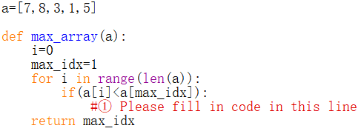

A: i=max_value

B: max_value = a[i]

C: max_value = i

D:a[i] = max_value

Answer: B (Zhou Liguang)

* 1. Consider the following program, which statement/s is/are correct?

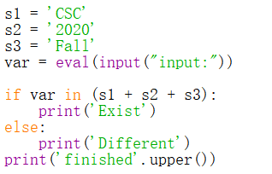

1. There is no syntax error in this program.
2. If the input is '2020', the output will be

Exist   
 FINISHED

1. If the input is 'CSCFALL', the output will be   
    Different   
    FINISHED
2. No matter what kind of input, the program will run failed.

Answer: A (Che Haoxuan)

* 1. Concerning one python list *list_a*, which of the following statement is correct?

1. *list_a* can only contain values of same type.
2. The last value in the list is *list_a(len(list_a))*.
3. The return value of *list_a.sort()* is None.
4. *list_a*2* is illegal in python.

Answer: C (Li Zhaoqun)

* 1. Concerning the object in Python, which of the following statements is incorrect?

1. You can use the id() function and type() function to get information about an object.
2. The type of an object is determined automatically by Python interpreter according to its value.
3. Every variable is essentially a reference to an object.
4. The ID of an object may be changed during the execution of the program.

Answer: D (Li Yishu)

* 1. Concerning the following program, which of the following statement is incorrect?

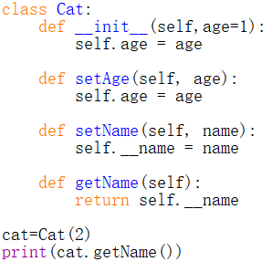

1. The __init__() function can be invoked out of the definition of class Cat.
2. The __init__() function is a private method.
3. The attribute self.__name in class Cat is private.
4. The output of the statement print(cat.getName()) will raise an AttributeError.

Answer: B (Zheng Yujian)

* 1. Concerning class inheritance in Python, which of the following statements is incorrect?

1. Inheritance extends the power of the object-oriented paradigm by adding an important and powerful feature for reusing software.
2. A subclass may inherit data fields and methods from its superclass.
3. When defining a subclass, the name of its superclass should be placed in the parenthesis after the name of the subclass.
4. A subclass is a subset of its superclass.

Answer: D (Li Yishu)

* 1. What is the output of the following code?

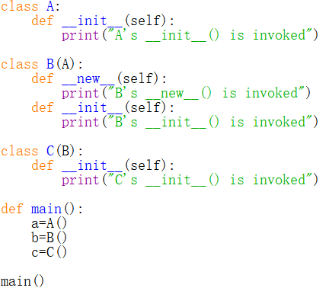

1. A's __init__() is invoked  
   B's __new__() is invoked  
   B's __init__() is invoked

C's __init__() is invoked

1. A's __init__() is invoked  
   B's __new__() is invoked  
   B's __new__() is invoked
2. A's __init__() is invoked  
   B's __new__() is invoked  
   B's __init__() is invoked

B's __new__() is invoked

1. A's __init__() is invoked  
   B's __new__() is invoked  
   B's __init__() is invoked  
   B's __new__() is invoked  
   C's __init__() is invoked

Answer: B (Zhao Huan)

* 1. Concerning data structure and algorithm, which of the following statements is incorrect?

1. Data structure is a systematic way of organizing and accessing data.
2. Experimental running times of two algorithms are difficult to directly compare unless the experiments are performed in the same hardware and software environments
3. When evaluating an algorithm, we only need to measuring its space usage.
4. Experimental analysis and asymptotic analysis are commonly used when analyzing the running time of an algorithm.

Answer: C (Li Yishu)

* 1. Concerning algorithm analysis, which of the following statements is correct?

1. In algorithm analysis, we focus on the growth rate of the running time as a function of the output size.
2. The result of asymptotic analysis depends on the hardware and software environment where you perform the algorithm.
3. An algorithm with a time complexity of O (n) will always cost more time than an algorithm with a time complexity of O (1).
4. Big O notation focuses on the fastest growing term and is useful in the analysis of algorithms.

Answer: D (Qiu Liangdong)

* 1. Concerning the following program

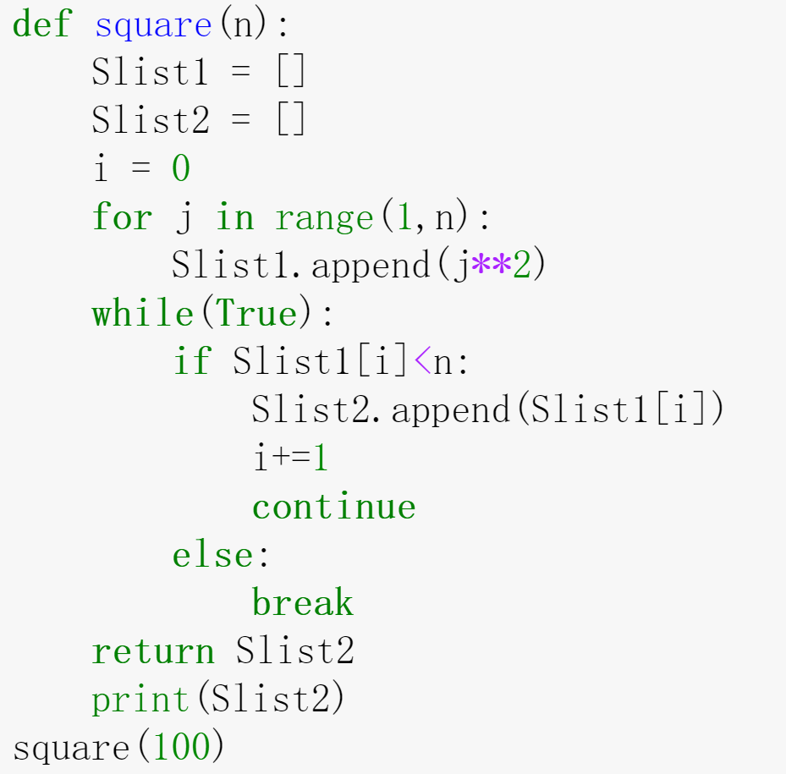

Which of the following statement/s is/are correct?

A. Function square() has only one return value.

B. Function square() uses a definite loop to return a list of numbers that are square with total list length that less or equal to the input parameter n.

C. The length of the list Slist2 has not been set beforehand.

D. The result of the program is shown as following:

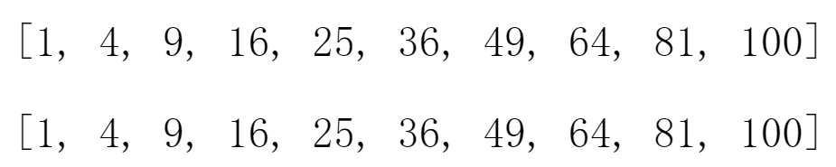

Answer: C (Ms Qianyu Zhang)

* 1. Concerning stack and queue, which of the following statement is correct?

1. A stack can be accessed based on the “first in last out” principle and the time complexity of inserting an element into a stack is constant.
2. More than one element of a stack can be accessed simultaneously if necessary.
3. Elements can be inserted at any time in a queue, but only the element that has been in the queue the longest can be next removed.
4. The time complexity of removing an element from a stack or a queue is linear.

Answer: C (Zhao Weibing)

* 1. Concerning linked list, which of the following statement/s is correct?

1. The time complexity of removing the head node of a singly linked list is linear.
2. Elements in a singly linked list must be with same data type.
3. A node in a circularly linked list usually contains two references pointing to its previous and next node.
4. We can identify the tail of a singly linked list as the node having None as its next reference.

Answer: D (Li Yishu)

* 1. Concerning the binary search algorithm, which of the following statement is correct?

1. This algorithm is able to find out whether a target element exists in a given sequence of elements.
2. Binary search algorithm can be applied on an unsorted sequence.
3. The time complexity of binary search is O(n).
4. Binary search is usually equally efficient compared with sequential search.

Answer: A (Zhao Huan)

Question 2. (10 × 4% = 40%)

Pick the correct option/s in each of the following sub-questions. Note that there may be MULTIPLE correct options for each sub-question(one, two, three or four correct options all possible). With any wrong options will get 0 point for that problem, while missing any correct options will get half(2 points).

* 1. Which of the following is/are a part of the Von Neumann architecture?

A. central processing unit B. graphical processing unit

C. main memory D. output device

Answer: ACD (Zhao Huan)

* 1. Concerning recursion, which of the following statement/s is/are correct?

1. Recursion is a technique by which a function makes one or more calls to itself during execution.
2. Factorial belongs to linear recursive algorithms.
3. A recursive algorithm should have only one base case which is non-recursive.
4. Recursion is used for performing a definite amount of repetitive tasks, the same as for loop.

Answer: AB (Zhang Qianyu)

* 1. Consider the following program, which of the following statement/s is/are correct?

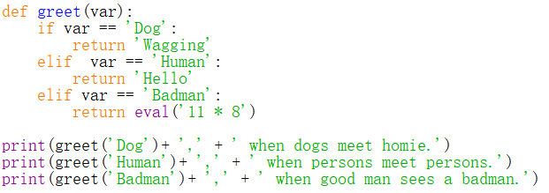

1. var is an argument of function greet().
2. The output of third print function will be:  
    88, when good man sees a badman.
3. Function greet() only has one return value.
4. Function greet() has only three hidden parameter.

Answer: C(Che Haoxuan)

* 1. Given the program, which of the following statement/s is/are correct?

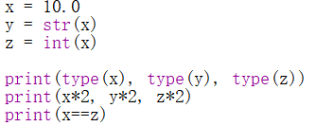

1. The output of the first print() is: <class 'float'> <class 'str'> <class 'int'>
2. The number of multiplications performed in this program is 3.
3. The output of the second print() is: 20.0 20.0 20
4. The output of the third print() is: True

Answer: AD(Chen Yu’ang)

* 1. Concerning the following program, which of the following statement/s is/are correct?

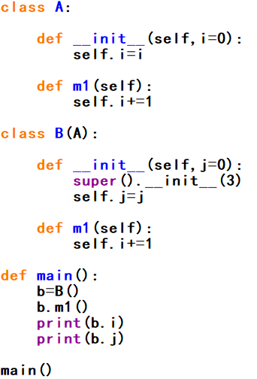

1. Class B() has only one superclass.
2. In class B(), the initializer of A() is accessed by calling function super().
3. Class B() has only one data field.
4. The output of b.i and b.j are 1 and 0.

Answer: AB (Zhao Weibing)

* 1. Concerning the following program, which of the following statement/s is/are correct?

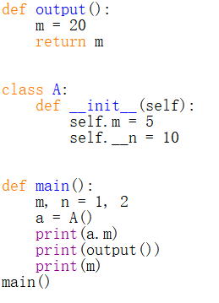

1. The value of global variable m will initially be set as 1, and then changed to 20.
2. In this program, three different variables m have been defined.
3. Data field n of class A() can not be accessed within main function.
4. The output of this program is:  
    5  
    20  
    20

Answer: BC (Qiu Liangdong)

* 1. Concerning the following program, which of the following statement/s is/are incorrect?

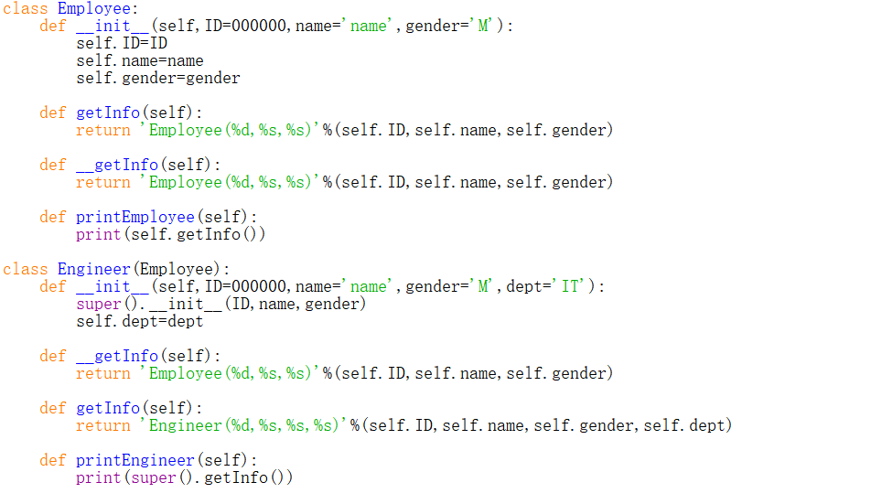

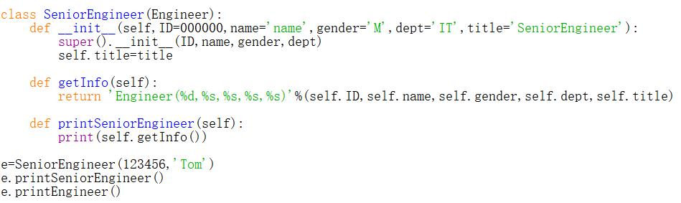

1. The output for this program is:  
    Engineer(123456,Tom,M,IT,SeniorEngineer)  
    Engineer(123456,Tom,M,IT)
2. The __getInfo() method in Engineer() class is inherited from Employee class.
3. The getInfo() method in SeniorEngineer() class has been overridden.
4. The e.printEngineer() method is actually invoke getInfo() method in Employee() class.

Answer: AB (Li Yishu)

* 1. Concerning the class in Python, which of the following statement/s is/are correct?

1. We can use the same name method to process objects differently depending on their class.
2. A subclass can inherit or override the public data fields and methods of its superclass.
3. A member with two leading underscores (e.g. *__a*) is private, which means we cannot access it in or outside the class.
4. The scope of a local variable in a method is within this method, we cannot access it outside the method.

Answer: ABD (Li Zhaoqun)

* 1. Concerning algorithm analysis, which of the following statement/s is/are correct?

1. The big-Oh notation allows us to say that a function f(n) is less than or equal to another function g(n) up to a constant factor when n is large enough.
2. The big-Oh notation is usually used to characterize the running time of an algorithm in the asymptotic sense.
3. Function $5n^{4}+6n^{3}+2n^{2}+2^{n}+2n$ is O($n^{4}$).
4. When we analyse an algorithm, we are usually interested in its running time and we do not care about its space usage.

Answer: AB (Zheng Yujian)

* 1. Assume that the elements 1, 2, 3, 4, and 5 are pushed onto the stack in sequence. If the first popped element is 4, the last popped element could be:

1. 1
2. 2
3. 3
4. 5

Answer: AD (Zhou Liguang)

Question 3. (9%+9%+12% = 30%)

Answer the following questions.

* 1. The following program is to compute the summation of the absolute difference of all distinct pairs in an given array.

Sample input array: [2, 1, 3]

All distinct pairs: [2, 1], [2, 3], [1, 3]

Sample output: 4

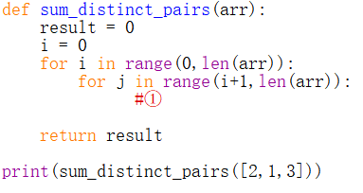

1. Please fill in the blank to implement the function required.(The fill-in codes could be more than one line)
2. Write the output for given program if the input array is updated as [5,9,4,1,7]
3. What’s the time complexity of this program.

Answer:

a)

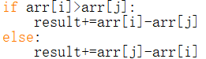

Or



b) 38

c) O(n²)

* 1. Concerning the following program

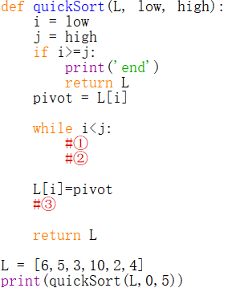

Answer the following questions:

1. This program is to sort a given list with descending order(the output of the above program is [10, 6, 5, 4, 3, 2]). Use quick sort to implement the sort. Please fill the blank ①② to complete the program. (The fill-in codes could be more than one line)
2. Please draw the recursive trace for this program.

Answer:

1. ①

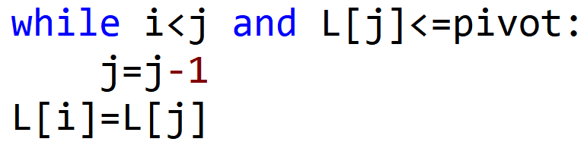

②

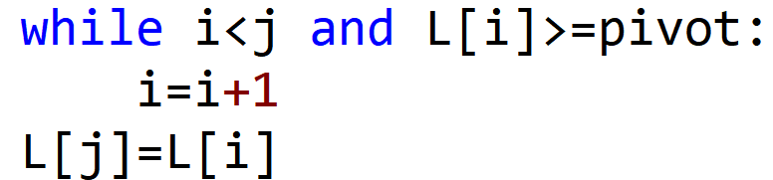

③

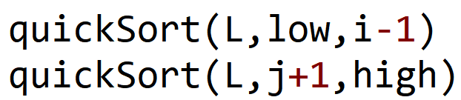  
b)

* 1. Let a binary search tree (BST) is defined as follows:  
     The left subtree of a node contains only nodes with elements less than the node's element.  
     The right subtree of a node contains only nodes with elements greater than the node's element.  
     Both the left and right subtrees must also be binary search trees.

1. In the given program, the function sorted_array_to_bst() is to create a Balanced Binary Search Tree (BST) using an array elements where array elements are sorted in ascending order. Please draw the binary search tree created for this program.

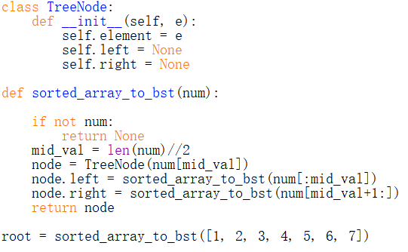

1. The code below is to implement Depth First Search (DFS) algorithm on a binary tree. The input t is the reference of tree root node. Please write the output of applying DFS on the tree created in Question (1).

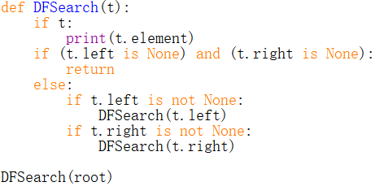

1. Write a function to find a node with minimum element from a binary search tree. (The fill-in codes could be more than one line)

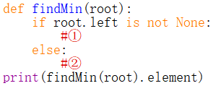

Answers:

a)

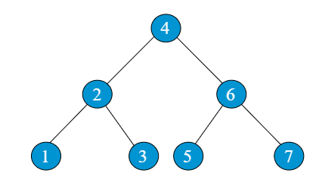

b)



c)

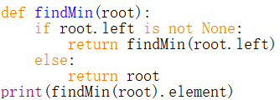

**END OF EXAMINATION**